NAAN MUDHAVAN ASSIGNMENT DOCUMENT

**COURSE TITLE** : DIGITAL MARKETING

**COLLEGE CODE** 1105

**COLLEGE NAME** : GOJAN SCHOOL OF BUSINESS AND TECHNOLOGY

**NM ID NAME**

**REGISTER NUMBER**

: 6A40DF85765D349AEA0455C8A9633108

: THAMEEM ANSARY A

: 110520106020

**YEAR** : 4TH YEAR

**DEPARTMENT** : ELECTRONICS AND COMMUNICATION ENGINEERING

1. Create a blog or website using Blogspot and Wordpress. Customize the theme design and post new article with 500 words.

Link: <https://freshworld20.blogspot.com/2023/10/fresh-world.html?m=1>



1. Create a New Facebook Or Social Media Business Page and post one social media poster for your Brand

Link: <https://www.facebook.com/profile.php?id=61552108291838>

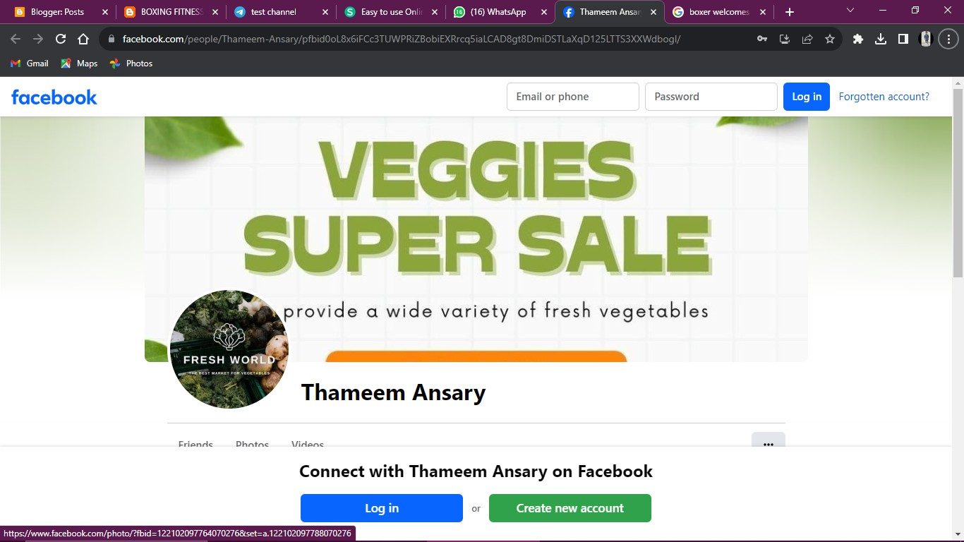

1. Create and design a social media advertisement poster using canva.

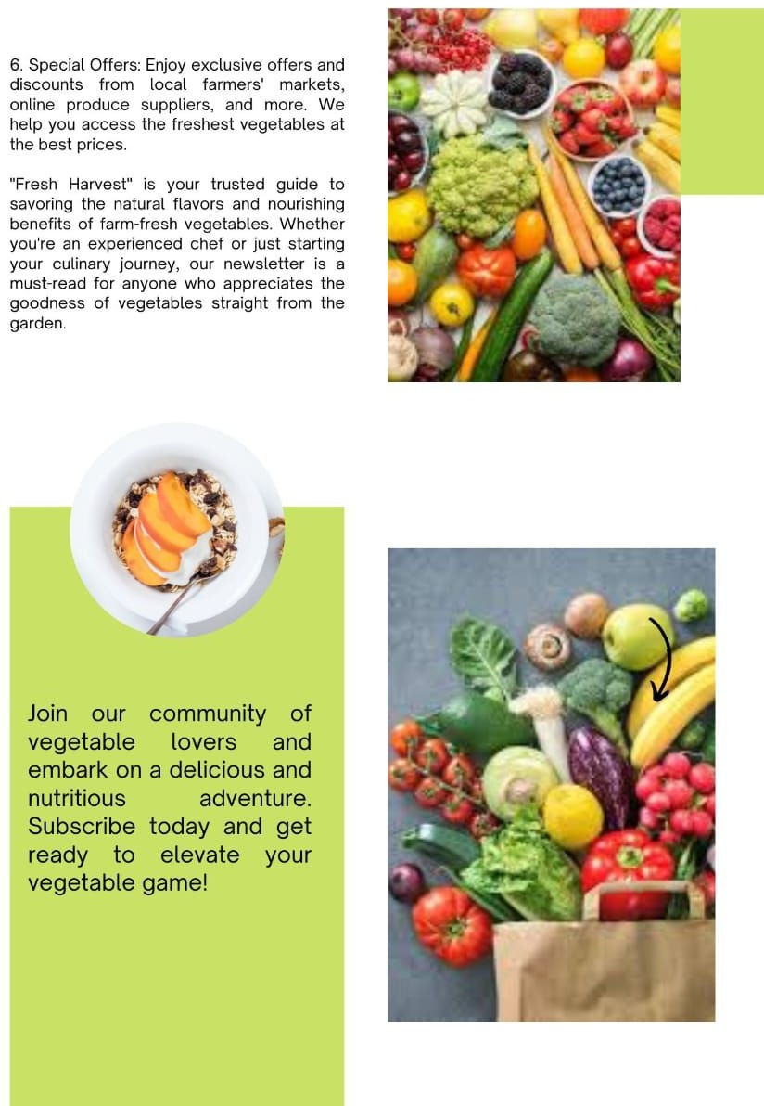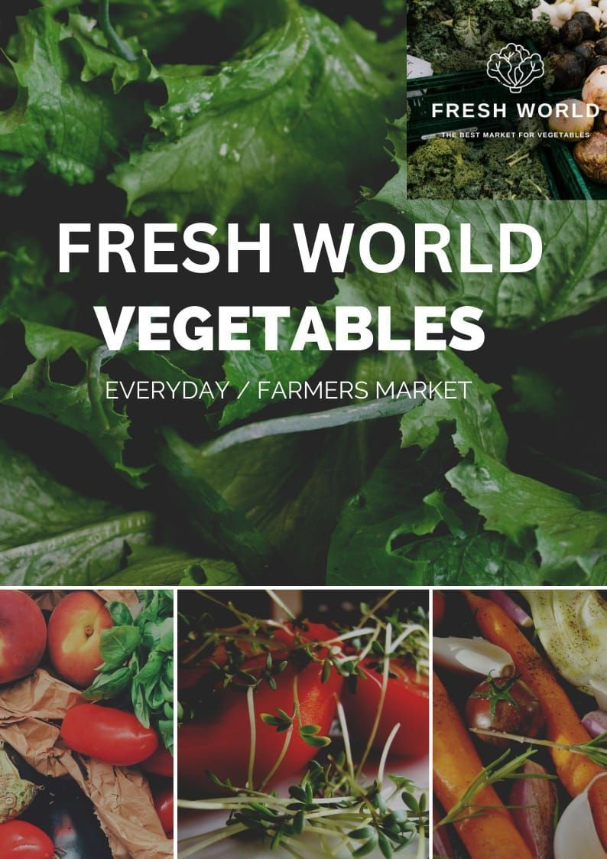

1. Create email newsletter design using MailChimp or canva tool. Link: <https://freshworld20.blogspot.com/2023/10/news-letter.html?m=1>

